Eyeconic - Glasses Shop Management System

Use-Case Specification: Edit Brands

Version 1.0

Revision History

|  |  |  |  |
| --- | --- | --- | --- |
| **Date** | **Version** | **Description** | **Author** |
| 05/11/2019 | 1.0 | Start creating use case | Đỗ Nguyễn Hoàng Ân |
|  |  |  |  |
|  |  |  |  |
|  |  |  |  |

Table of Contents

1. Edit Brands 4

1.1 Brief Description 4

1.2 Basic Flow 4

2.2 Exception 5

2.2.1 Edit brands 5

2.2.2 Fill in the brands information 5

2. Special Requirements 5

3. Preconditions 5

4. Postconditions 5

5. Extension Points 5

Use-Case Specification: Edit Brands

# Edit Brands

## Brief Description

This use cacse defines the step of removing existing Brands from the database.

Brands are removed by the admin.

## Basic Flow

The system administration selects the Brands data to edit. The administrator changes the needed information. The system displays the updated management parameter value and logs the change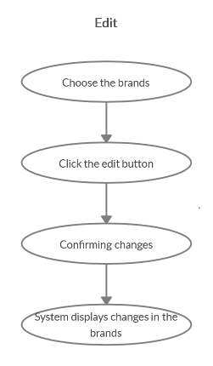

***Basic flow of Editing Brands***

Step 1: Choose the brands you want to edit

Step 2: Click edit button

A modal view shows up

Edit the change needed

Step 3: Confirming adding the brands by clicking the “Save” button.

Step 4: Successful information changed brands are displayed on the screen

## 2.2 Exception

### 2.2.1 Edit brands

The add button cannot be clicked or isn’t appeared on the screen

### 2.2.2 Fill in the brands information

Invalid information.

2.2.3 Confirming editing the brand

The “Save” button is clicked but the new information of the brands are not changed.

2.2.4 System displays added brand

The edited brand’ informations are not display correctly.

# Special Requirements

# Preconditions

User must already login as the administrator of the website.

# Postconditions

Brand information is changed and can be purchased by customers.

# Extension Points

Administrator check the website and the system to ensure that the edited information of the Brands is correct.